Project Design Phase
Solution Architecture Document
An employee requests installation of licensed software through the Service Catalog
Date | 3-09-2026
Team ID | SWUID2026190351
Project Name | An employee requests installation of licensed software through the Service Catalog
Maximum Marks | 4 Marks

1. Solution Architecture Overview
Solution architecture bridges the gap between organizational software request challenges and ServiceNow technical implementation. Its primary goals for this project are:
• Find the best cloud-native ITSM workflow solution to eliminate software access bottlenecks.
• Describe the structural relationship between Service Portal forms, Catalog Workflows, Fulfillment Tasks, and Business Rules.
• Define technical specifications ensuring seamless auto-approvals, correct group task assignments, and state-driven trigger executions.

2. ServiceNow System Architecture & Data Flow Diagram
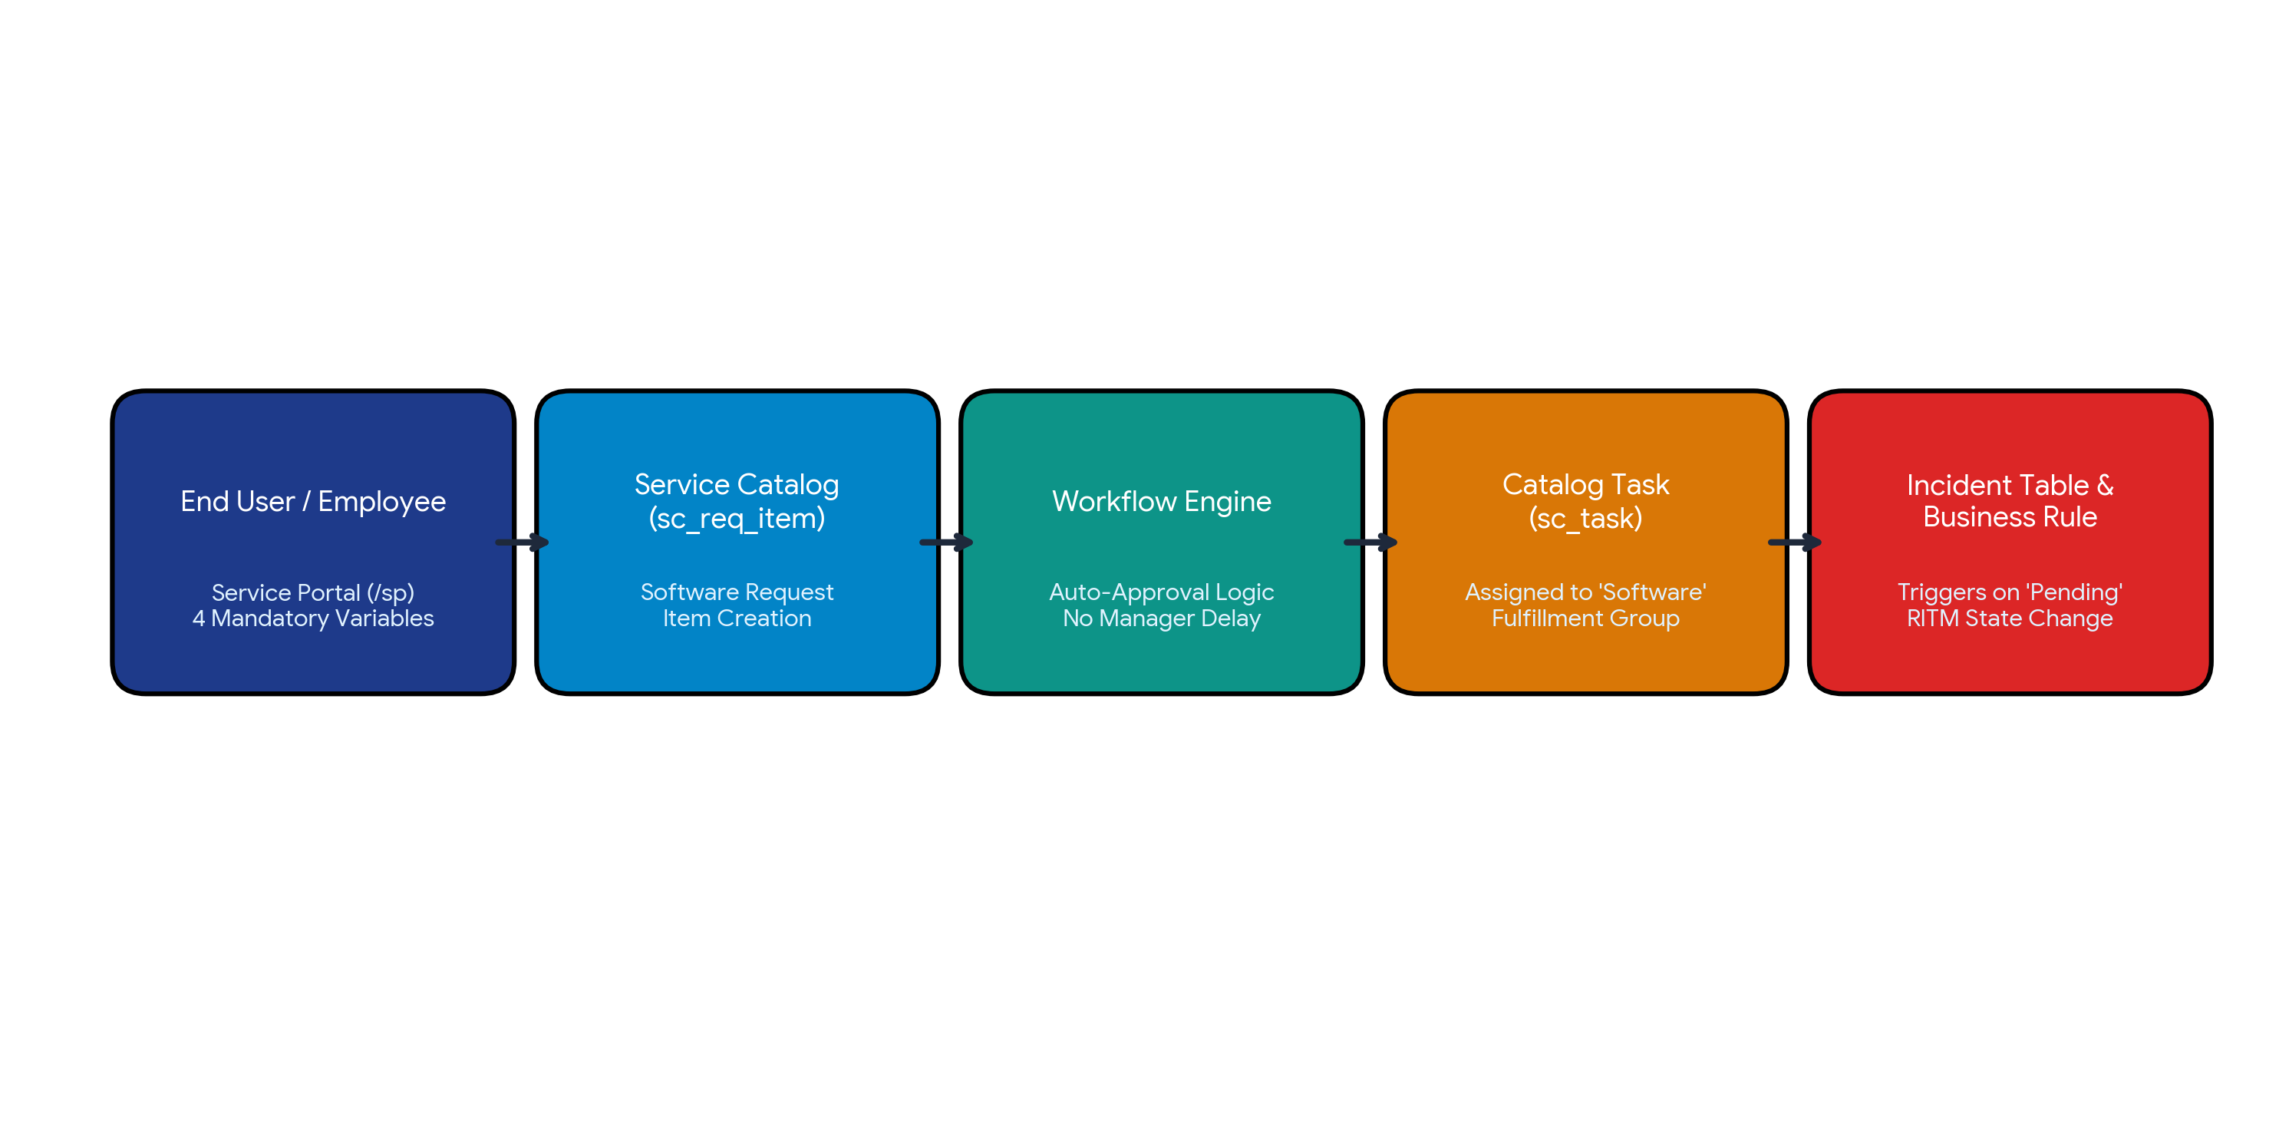
Figure 1: ServiceNow Architecture and Data Flow for Employee Software Request & Automated Fulfillment

3. Architectural Component Specifications
Component | ServiceNow Element | Technical Specification & Behavior
User Interface Layer | Service Portal (`/sp`) | Provides a clean self-service form capturing 4 mandatory catalog variables: Software Name, Version, Justification, and Workstation ID.
Request Engine | Service Catalog (`sc_req_item`) | Generates the Requested Item (RITM) upon form submission and attaches key metadata required for fulfillment.
Workflow Engine | Workflow Studio / Workflow | Executes automated business logic that bypasses manual manager approvals for standard software, enabling instant approval.
Task Fulfillment Layer | Catalog Task (`sc_task`) | Automatically generates a fulfillment task assigned directly to the 'Software' assignment group for IT execution.
Automation & Logic Layer | Incident Table & Business Rule | Executes server-side Business Rules on the Incident table whenever a Requested Item (RITM) state transitions to 'Pending'.

